BookItNow

Software Requirements Specification

10-04-2024

Baikadi Vinay

Prepared for
Continuous Assessment 3
Spring 2024

Revision History

Date | Description | Author | Comments
<date> | <Version 1> | <Your Name> | <First Revision>

Table of Contents

Revision History ii
CLIENT Approval ii
1. Introduction 1
1.1 Purpose 1
1.2 Scope 1
1.3 Definitions, Acronyms, and Abbreviations 1
1.4 References 1
1.5 Overview 1
2. General Description 2
2.1 Product Perspective 2
2.2 Product Functions 2
2.3 User Characteristics 2
2.4 General Constraints 2
2.5 Assumptions and Dependencies 2
3. Specific Requirements 2
3.1 External Interface Requirements 3
3.1.1 User Interfaces 3
3.1.2 Hardware Interfaces 3
3.1.3 Software Interfaces 3
3.1.4 Communications Interfaces 3
3.2 Functional Requirements 3
3.2.1 <Functional Requirement or Feature #1> 3
3.2.2 <Functional Requirement or Feature #2> 3
3.5 Non-Functional Requirements 4
3.5.1 Performance 4
3.5.2 Reliability 4
3.5.3 Availability 4
3.5.4 Security 4
3.5.5 Maintainability 4
3.5.6 Portability 4
3.7 Design Constraints 4
3.9 Other Requirements 4
4. Analysis Models 4
4.1 Data Flow Diagrams (DFD) 5
5. Github link…………………………………………………………………………………………………….5
5. CLIENT APPROVAL PROOF……………..…………………………………………………………………….5
A. Appendices 5
A.1 Appendix 1 5
A.2 Appendix 2 5

Introduction
Welcome to the Software Requirements Specification (SRS) for the BookItNow website. This document outlines the requirements for the development of an online platform that allows users to browse, select, and order food by sitting in the restaurant without the help of waiters from a variety of restaurants in their vicinity. And also allows restaurants to display their menu on the website and take orders directly online, so that they can save money and time invested on waiters.

1.1 Purpose
The purpose of the BookItNow website is to provide a convenient and efficient way for users to satisfy their dining needs by offering a seamless online food ordering experience. By leveraging technology, this platform aims to bridge the gap between customers and restaurants, facilitating food serving to the table and Billing online in user’s interface.

1.2 Scope
The primary software product to be developed is the BookItNow website, a comprehensive online platform facilitating food ordering and serving services.

This website will:
- Allow users to register and log in securely.
- Provide a user-friendly interface for browsing restaurants and their menus.
- Support various payment methods and ensure secure transaction processing.
- Offer administrative tools for restaurant owners to manage their menus, orders, and accounts.

This website will not:
- Handle physical food preparation or delivery; it will only facilitate the ordering process between users and restaurants.
- Store sensitive payment information: instead, it will securely interface with third-party payment gateways.
The main goal and the benefit of the website is to provide seamless experience to the customer by providing menu to them on their own mobile phone and also reduce the time and cost complexity to the restaurant owners.

1.3 Definitions, Acronyms, and Abbreviations
User: Refers to any individual who accesses the BookItNow website to browse restaurants, place orders, or perform other related actions.
Restaurant Owner/Administrator: Denotes the proprietor or authorized personnel responsible for managing a restaurant's presence on the BookItNow platform.
SRS: Software Requirements Specification; a document outlining the requirements for the development of the BookItNow website.
API: Application Programming Interface; a set of rules and protocols for building and interacting with software applications.
UI: User Interface; the visual elements and design layout of the BookItNow website that users interact with.
UX: User Experience; the overall experience and satisfaction level of users when using the BookItNow website.
HTTP: Hypertext Transfer Protocol; the protocol used for transferring data over the World Wide Web.
HTTPS: Hypertext Transfer Protocol Secure; an extension of HTTP that ensures secure communication over a computer network.
HTML: Hyper Text Markup Language.
CSS: Cascading Style Sheets.
MongoDB: A cross-platform document-oriented NoSQL database program. It uses a JSON-like format for storing data, making it flexible and scalable for various applications, including web development.
Node.js: An open-source, cross-platform JavaScript runtime environment that executes JavaScript code outside of a web browser. It enables server-side scripting and facilitates the development of scalable network applications.
Mongoose: An object modeling tool for Node.js and MongoDB. It provides a straightforward schema-based solution to model application data, including built-in type casting, validation, query building, and business logic hooks.

References
W3Schools:
https://www.w3schools.com/html/
https://www.w3schools.com/css/
https://www.w3schools.com/js/
https://www.w3schools.com/nodejs/
https://www.w3schools.com/nodejs/nodejs_mongodb.asp
freeCodeCamp: https://www.freecodecamp.org/
Swiggy: https://www.swiggy.com/
Zomato: https://www.zomato.com/india

1.5 Overview
BookItNow aims to streamline the restaurant dining experience by allowing customers to order food directly from their table without the need for a waiter. The application will provide a platform for both customers and restaurant owners to interact seamlessly.

2. General Description
The BookItNow website is an innovative online platform designed to revolutionize the food ordering experience. It serves as a centralized hub where users can discover, explore, and order food from a diverse selection of restaurants within their vicinity. The system provides a seamless and intuitive interface for users to browse restaurant menus, customize orders, make payments, and track deliveries in real-time.

2.1 Product Perspective

BookItNow will serve as a standalone web application interacting with databases to store user information, restaurant menus, and order details. It will integrate with payment gateways for bill processing.

2.2 Product Functions

User registration and login

Restaurant and menu browsing

Food ordering and customization

Bill generation

Restaurant owner dashboard for menu management and order tracking

2.3 User Characteristics

The users of BookItNow will primarily consist of restaurant customers and owners. Customers should have basic knowledge of using web applications, while owners will require additional knowledge for menu management.

2.4 General Constraints
Compatibility with modern web browsers
Compliance with data protection regulations
Dependence on internet connectivity for real-time order processing.

2.5 Assumptions and Dependencies
Availability of stable internet connections for both customers and restaurant owners
Adequate security measures to protect user data.

3. Specific Requirements
In this section, we elaborate on the specific requirements of the BookItNow web application. These requirements encompass various functionalities and features that are essential for the successful development and deployment of the system.

3.1 EXTERNAL INTERFACE REQUIREMENTS

3.1.1 User Interfaces
The user interface of BookItNow should be intuitive, user-friendly, and visually appealing to enhance the user experience. It should comprise the following elements:

Homepage: The homepage should provide an overview of available restaurants and options for user registration or login.
Restaurant Listings: Users should be able to browse restaurants based on location, cuisine, or popularity. Each restaurant listing should include essential details such as name, location, ratings, and a brief description.
Menu Display: Upon selecting a restaurant, users should be presented with a detailed menu showcasing available dishes, along with descriptions, prices, and images.
Order Placement: A seamless order placement process should be facilitated, allowing users to customize their orders (e.g., specifying portion size, adding special instructions).
User Profile: Registered users should have access to a profile dashboard where they can view order history, manage account settings, and update personal information.
Owner Dashboard: Restaurant owners should have a separate dashboard for menu management, order tracking, and performance analytics.

3.1.2 Hardware Interfaces
BookItNow should be compatible with a wide range of devices, including smartphones, tablets, laptops, and desktop computers. The application should adapt its layout and functionality based on the screen size and capabilities of the device used by the user.

3.1.3 Software Interfaces
The application should integrate with external software components to enable various functionalities:
Payment Gateways: Integration with payment gateways such as PayPal, Stripe, or Square for secure online transactions.
Database Management System (DBMS): Interaction with a relational database management system (e.g., MySQL, PostgreSQL) for storing user data, restaurant information, menus, and order details.

3.1.4 Communications Interfaces
BookItNow should ensure secure communication between clients and servers to safeguard sensitive information during data exchange. This involves the use of encryption protocols (e.g., SSL/TLS) to protect user credentials, payment information, and other personal data.

3.2 FUNCTIONAL REQUIREMENTS

3.2.1 User Registration and Authentication
User Registration: New users should be able to create accounts by providing basic information such as name, email address, and password. Email verification may be implemented to ensure the validity of user accounts.
User Authentication: Registered users should be able to log in securely using their email address and password. Authentication mechanisms should be implemented to prevent unauthorized access to user accounts.

3.2.2 Restaurant and Menu Browsing
Search Functionality: Users should be able to search for restaurants based on various criteria, including location, cuisine type, or restaurant name.
Menu Navigation: Once a restaurant is selected, users should be able to navigate through the menu easily, with options for filtering by category (e.g., appetizers, main courses, desserts).
Item Details: Detailed information about each menu item should be provided, including ingredients, dietary information, and any special instructions or customization options.

3.2.3 Order Management
Order Placement: Users should be able to add items to their cart, review their orders, and proceed to checkout for payment.
Order Customization: Users should have the option to customize their orders (e.g., choosing side dishes, specifying cooking preferences, adding special instructions).
Order Tracking: Users should receive real-time updates on the status of their orders, including confirmation of order receipt, preparation, and estimated delivery or pickup time.

3.2.4 Billing and Payment
Billing: Upon order confirmation, users should receive a detailed bill summarizing their order items, quantities, prices, and any applicable taxes or fees.
Payment Options: Multiple payment options should be supported, including credit/debit cards, digital wallets (e.g., Apple Pay, Google Pay), and cash on delivery/pickup.

3.2.5 Restaurant Owner Features
Menu Management: Restaurant owners should be able to upload, edit, and remove menu items as needed. They should also have the option to set prices, descriptions, and availability status for each item.
Order Processing: Restaurant owners should receive notifications of incoming orders and have the ability to accept, reject, or modify orders based on availability and preparation time.
Performance Analytics: Insights into order trends, customer feedback, and sales metrics should be provided to restaurant owners to optimize menu offerings and operational efficiency.

3.5 NON-FUNCTIONAL REQUIREMENTS

3.5.1 Performance
BookItNow should be able to handle a large volume of concurrent users without experiencing performance degradation. Response times for user interactions such as menu browsing, order placement, and payment processing should be optimized to ensure a smooth and responsive user experience.

3.5.2 Reliability
The application should be reliable and robust, with minimal downtime or system failures. Fault tolerance mechanisms should be in place to handle unexpected errors gracefully and ensure uninterrupted service availability.

3.5.3 Availability
BookItNow should be available 24/7, allowing users to access the application and place orders at any time. Scheduled maintenance periods, if necessary, should be communicated to users in advance, with minimal disruption to service.

3.5.4 Security
Security measures should be implemented to protect user data, including personal information, payment details, and order history. Encryption protocols should be used to secure data transmission, while access control mechanisms should prevent unauthorized access to sensitive information.

3.5.5 Maintainability
The application should be designed and implemented following best practices to facilitate ease of maintenance and future updates. Modular code architecture, comprehensive documentation, and version control systems should be employed to streamline the development process and support ongoing maintenance efforts.

3.5.6 Portability
BookItNow should be compatible with a wide range of web browsers and devices to accommodate diverse user preferences and ensure accessibility. Responsive design techniques should be utilized to adapt the application layout and functionality across different screen sizes and resolutions

3.7 DESIGN CONSTRAINTS

BookItNow must adhere to the following design constraints:

Responsive Design: The application must be designed to provide a consistent user experience across different devices and screen sizes. Responsive design techniques, such as fluid layouts and media queries, should be employed to ensure optimal display on smartphones, tablets, laptops, and desktops.
Scalability: The architecture of BookItNow should be scalable to accommodate future growth in user base and transaction volume. Scalability considerations should be integrated into the design to allow for seamless expansion of infrastructure and resources as needed.
Modularity: The system should be modularly designed to facilitate flexibility, reusability, and maintainability of code components. Modular design principles, such as encapsulation and separation of concerns, should be followed to enable easier development, testing, and updates.
Data Privacy and Compliance: BookItNow must comply with data privacy regulations, such as GDPR (General Data Protection Regulation) and CCPA (California Consumer Privacy Act). Personal data collected from users must be handled securely and in accordance with applicable laws and regulations.

3.9 OTHER REQUIREMENTS

In addition to the functional and non-functional requirements mentioned earlier, the following requirements must also be considered:

Accessibility: BookItNow should be designed to be accessible to users with disabilities, in compliance with WCAG (Web Content Accessibility Guidelines) standards. Features such as keyboard navigation, screen reader compatibility, and alternative text for images should be implemented to ensure inclusivity.
Localization: The application should support multiple languages and currencies to cater to a diverse user base. Localization features, such as language selection and currency conversion, should be provided to enhance usability for international users.
Integration with External Systems: BookItNow may require integration with external systems such as third-party delivery services, inventory management systems, or loyalty programs. APIs (Application Programming Interfaces) should be used to facilitate seamless communication and data exchange between the application and external systems.
Feedback and Support: Mechanisms for collecting user feedback and providing customer support should be implemented within the application. Users should have the ability to submit inquiries, report issues, and receive timely assistance from customer support representatives.
Regulatory Compliance: The application should comply with industry-specific regulations and standards, such as food safety regulations for restaurants and PCI DSS (Payment Card Industry Data Security Standard) for handling payment card data. Compliance checks and audits may be required to ensure adherence to relevant standards.

4. Analysis Models
List all analysis models used in developing specific requirements previously given in this SRS. Each model should include an introduction and a narrative description. Furthermore, each model should be traceable the SRS’s requirements.

4.1 Data Flow Diagrams (DFD)
Level 0 DFD
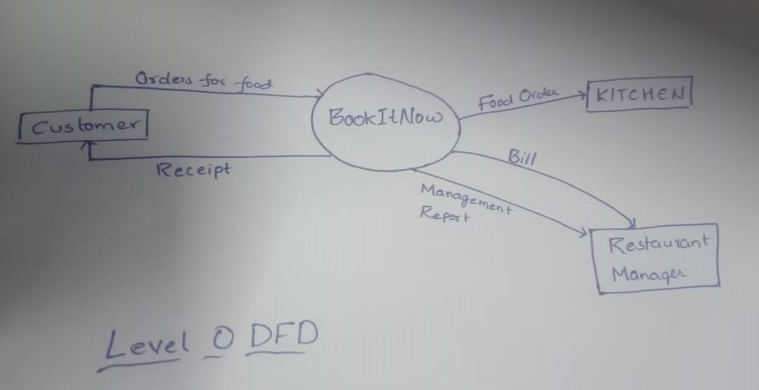

LEVEL 1 DFD
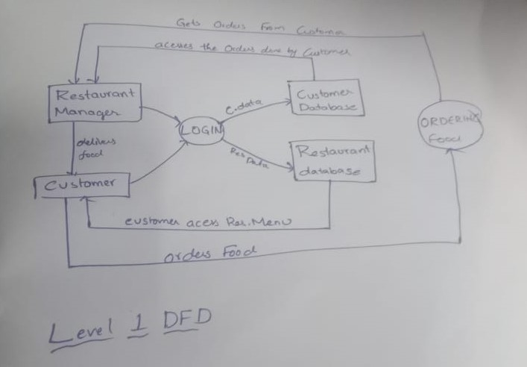

GITHUB link:

A. Appendices
Use Case Diagram

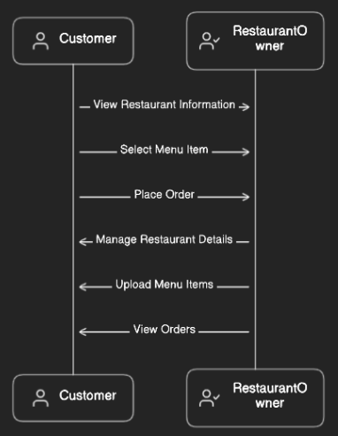

A.2 Appendix 2
• Entity-relationship diagrams
